- Consider the generator polynomial G(x) = x8 + x7 + x + 1
  - Assume that the data frame is 101101011010. What will be the transmitted bit stream?
- You are hired to design the network topology of an old university. To improve reliability, you decide to put two bridges to connect the segment of the EE department and that of the CS department. One network administrator told you that such topology will not work because it has a loop and since LANs do not have TTL, frames will loop forever. Do you need to change your design? If so, how? If no, why?
- Tunneling is a common technique used in the Internet. Give three examples in which we have used tunneling.
- In one sentence, describe the major reason that we need to use longest prefix matching for packet forwarding.
- Assume that the voltage level at time t = 0 is high, fill in the diagram below to show Manchester encoding for the bit stream 10111011.

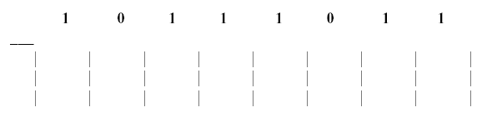
- Consider the network shown below. Show the operation of Dijkstra’s (Link State) algorithm for computing the least cost path from E to all destinations. Also, explicitly list the shortest path routes from E to all destinations that are the result of the algorithm’s computation. Show the distance table that would be computed by the distance vector algorithm in B. Note: you do not have to run the distance vector algorithm; you should be able to compute the table by inspection.

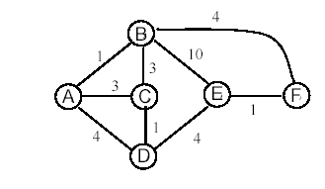
- ICMP:
  - Write out the abbreviation ICMP and explain the term briefly.
  - Explain briefly the relation between ICMP and IP.
  - Explain briefly the three (most usual) ICMP-message types.
  - Should a router give ICMP messages priority over normal traffic? Why or why not?
  - Give an example of an application that uses ICMP.
  - On top of which lower layer protocol does ICMP work?
- IP:
  - Write in decimal form the IP-address C22F1582. To which address class it belongs to? Write the address also in binary form.
  - What is the network part in the address 172.16.10.50/27? What is the host part?
  - How many subnets are available in the network mentioned above? How many hosts can be in one subnet?
- ARP
  - In what type of network is ARP used?
  - Explain (the main features of) the operation of the ARP.
  - Why is ARP needed? (2 points)
- Compare vector-distance and link-state protocols. Give one example of both.
- Explain briefly what a firewall is and what it is used for?
- What kind of operations or functions does a firewall typically handle (name three)?
- Given the following packet
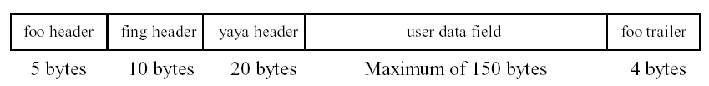
  - Sketch the layered protocol model that applies to this packet. Label each layer with its appropriate name.
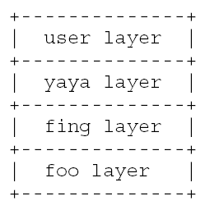
  - If the maximum length for the user data field is 150 bytes, what is the overhead (as a percentage) to send a 1600 byte user message? Will need ceil(1600 / 150) = 11 packets. Each packet has 39 bytes of overhead. So, 390 bytes of headers and trailers (overhead) is required to send 1600 bytes of user data, or 390 / (1600 + 390) = 19.6% overhead.
  - What is the likely function of the foo layer trailer field? The foo trailer is likely an error detection code of some sort.
- Describe IEEE 802.3 Ethernet. You should describe the intended application of Ethernet, CSMA/CD, frame format, addressing, frame lengths (what are they and why), topology, history, and scalability to higher speeds and larger spans. IEEE 802.3 Ethernet is LAN technology originally intended to support data networking in a single building with 1024 attached stations, about 2 kilometer span, and 10-Mbps data rate. Ethernet uses Carrier Sense Multiple Access / Collision Detection as its MAC protocol to share a common medium. The CSMA/CD protocol is:
(1) if (medium is idle) then xmit
(2) if (medium is busy) then wait until idle and when idle xmit immediately
(3) if (detect a collision when xmitting) then stop xmitting immediately
and back-off a random period of time
(4) goto (1)
The Binary Exponential Backoff (BEB) protocol for determining back-off time is:
while (attempts < 10)
k = min(attempts, 10)
k = rand(0, 2**k)
delay = r * slot_time
The frame format is as follows:
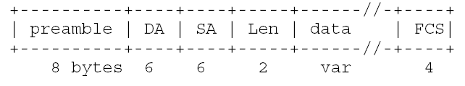Where the minimum packet length is 64 bytes based on a 2 * t_pr minimum length for CD before transmission complete in a 2 kilometer span network. The maximum packet length is 1500 bytes based on a historic 1K block size and that putting 1500 bytes of memory on a card was the maximum feasible. Addresses (SA) are uniquely defined in each adapter and destination addresses can be either to a specific address or to broadcast (all stations - address of all 1’s).
The topology of Ethernet is logical bus and has evolved from a physical direct-wired bus (10BASE5 and 10BASE2) to star-wired (e.g., 10BASE-T). Ethernet was invented by Metcalfe in 1976 motivated by Abramson’s ALOHA packet radio. From 1976, Ethernet has evolved from coax 10BASE5 and 10BASE2 to UTP 10BASE-T and 100BASE-T. Scalability of CSMA/CD is limited by the need for a minimum frame length to be 2*t_pr, thus future 10-Gbps Ethernet does not specify CSMA/CD.
- Describe layer-2 bridging. Describe the bridging table and forwarding/learning algorithm. Explain why a spanning tree is needed. Give the three names used for a bridge and describe how each name is appropriate. Layer-2 bridging serves as a MAC level filter between LANs with like MACs. The bridging table contains MAC addresses of all observed stations in the network and a direction for each address (local = “behind this port” or not local = “ahead of this port”). The key algorithm is:
  - Receive a frame (interface is promiscuous)
  - If (DA in table) and (DA local) then do not forward else forward
  - If (SA in table) check/update direction
  - If (SA not in table) add to table with direction
A spanning tree is needed to prevent loops. Loops would confuse the learning algorithm (i.e., the bridge would never learn on “what side” is a station) and cause infinite propagation of frames in the loop. Three names are: “Transparent bridge” because the bridge is “transparent” to end stations (i.e., no changes are needed in the end stations). “Learning bridge” because the bridge learns its forwarding table as described above. And, “spanning tree bridge” because the network of bridges must form a spanning tree for correct operation.
- 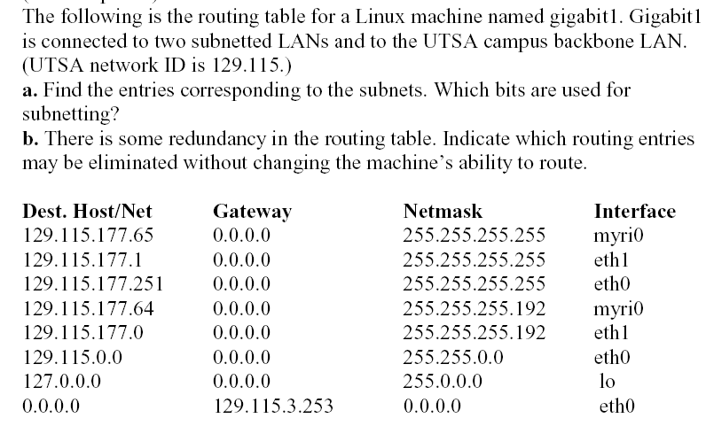
- 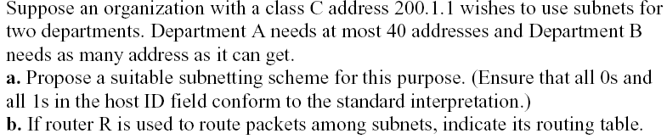
- 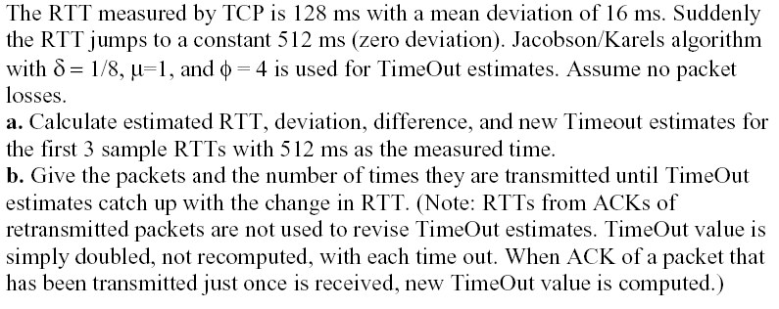
- For Tr = 10011 (received frame) and P = 11 (CRC generator polynomial), determine if Tr has a detectable error. Why is modulo-2 arithmetic used in calculating CRC's?
- Describe how an IP router works.
- Answer the following questions regarding circuit and packet switching
  - Describe circuit switching.
  - Describe the two “flavors” (or fundamental methods) of packet switching.
    - The two flavors of packet switching are datagram and virtual circuit. In datagram PS each packet is handled independently by the network (and packets may arrive out of order). In virtual circuit PS a path is established before data transfer and all packets in a session take the same path.
  - Describe the overheads present in packet switching and in circuit switching.
    - In packet switching there are overhead bits in all packets (headers and trailers) needed for protocol communication. In circuit switching, the overhead is in the time to establish a circuit and tear it down before and after data transfer.
- Assume that signal propagation is 1 foot per nanosecond. Given a 10-mile span (there are 5280 feet in a mile) between two stations and a data rate of 1-Mbps, what is the minimum frame size for CSMA/CD to work? You may assume that no repeaters are needed. Is CSMA/CD a viable protocol for this use?
  - Tpr = 5280 ft/mi* 10 mi * 1e-9 sec/ft= 52.8 microseconds So, a slot time is 105.6 microseconds At 1-Mbps a bit is 1 microsecond, so the minimum frame size is 105.6 bits, or about 14 bytes. Thus, CSMA/CD is viable for this application.
- Answer the following questions regarding bridging.
  - Describe what is a bridge and what it does? Be specific. If a figure will help, then draw one.
    - A bridge is a MAC-level filter. For a bridge between two LANS, it forwards only frames that are not addressed to stations known to be local to "this side" LAN.
  - Give the algorithm for frame forwarding and table learning for a transparent bridge.
(1) receive a frame
(2) if ((DA in table) and (DA not local)) then not forward else forward
(3) if (SA in table) check/update direction
(4) if (SA not in table) add to table
  - How did a transparent bridge get its name (i.e., "transparent")?
    - A transparent bridge does not require any changes or actions on the part of the end-stations. Thus, the installation of a transparent bridge is "transparent" to the end-stations and this explains its name.
  - What is the spanning tree algorithm and why is it needed?
    - The Spanning Tree (ST) algorithm is a private algorithm between all bridges in a network. The ST algorithm identifies parallel bridges and disables parallel bridges in such a way an acyclic tree of bridges is formed. The ST algorithm is needed to prevent loops in the bridged network where such loops would cause endlessly circulating frames (due to how the forwarding and table learning algorithm is implemented). The disabled parallel bridges are in an active standby state and can be put into active forwarding mode by the ST algorithm if the ST algorithm detects that an active bridge has failed.
- What information is needed in the routing table of Router1 in order that routing will work properly in the network of below figure? Clouds are subnetworks and boxes with crosses are routers. Inside asubnetwork, there are the IP addresses of the network. The IP address of the router’s network connection is next to the line from the subnetwork to the router.
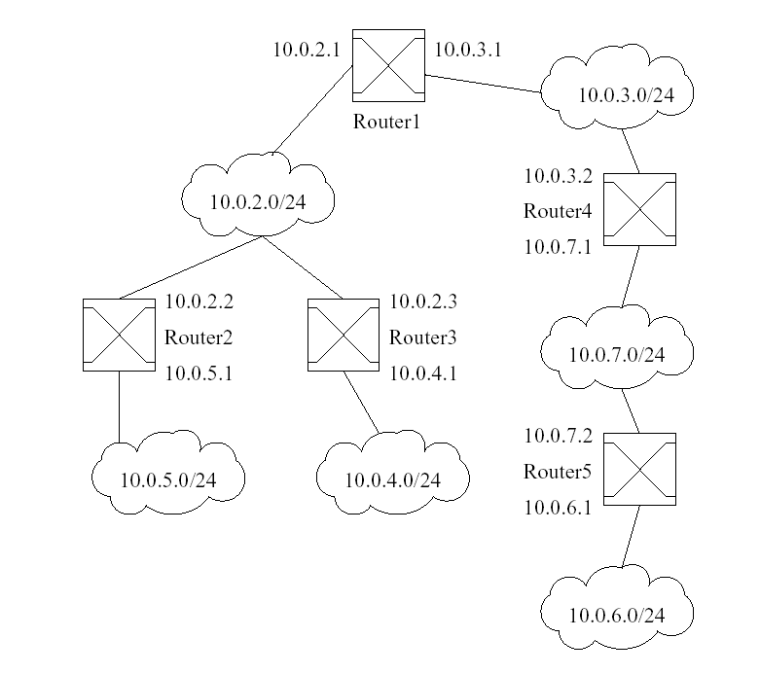
- Assume CSMA/CD protocol. Find the minimum frame length for a 1-Mbps bit rate and maximum network span of 10 kilometers with no repeaters. Assume a medium propagation delay of 4.5 nanoseconds per meter. Is CSMA/CD a reasonable protocol for a network of this span and bit-rate?
  - Minimum frame size for CSMA/CD is 2 * Tpr. Tpr = (4.5 * 10^-9)*(10 * 10^3) = 4.5 * 10^-5 sec. Thus, (1.0 * 10^6) * (9.0 * 10^-5) = 11.25 bytes. CSMA/CD would be a very reasonable protocol for a network of this span and speed since the minimum frame size is not “excessive” (e.g., larger than 64 bytes).
- When is ICMP Redirect message used, who sends it, and to whom is sent?
- 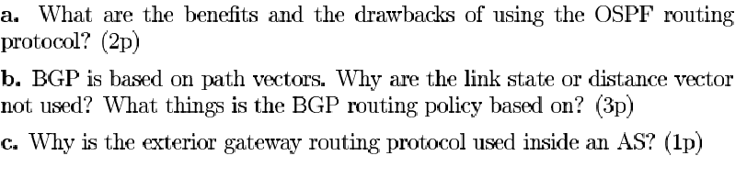
- 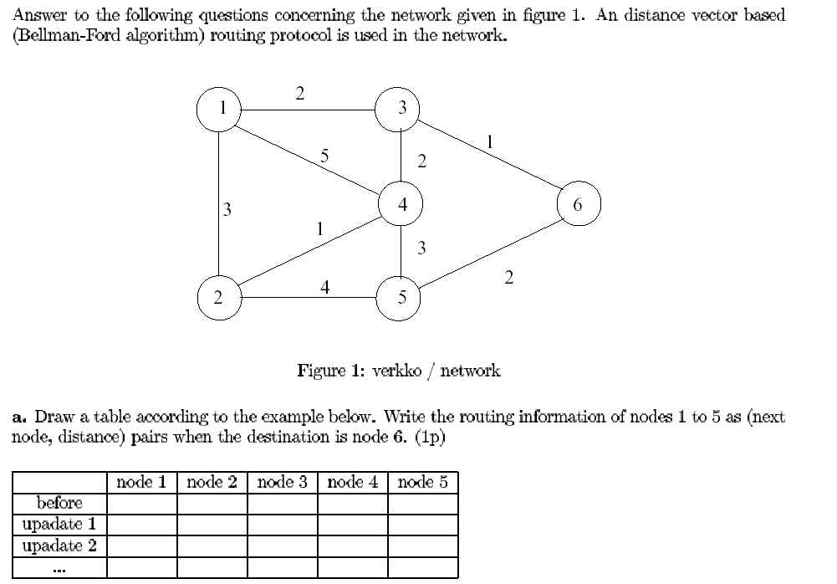
- 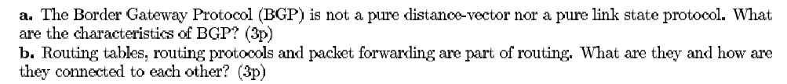
- Suppose you want to move a database from its current location to a new location (and computer) that is three hours driving time away. The data has been copied on to 50 DVDs, each containing 4.7GB of data. What is the effective data rate of this transfer (not counting the time for reading or writing the DVDs)?
- Why is UDP used instead of TCP in applications such as video streaming?
- A bit string sent to the link layer is 100111110111100101111110. What is the string, as transmitted, after bit stuffing?
- Find the bit stream transmitted, using the standard CRC encoding, when the data stream is 10011101. Use the generator polynomial x³ + 1. If the fourth bit from the left is inverted during transmission, show how this error is detected at the receiver.
- A LAN using Manchester encoding runs at 200 megabaud. What is its bit rate?
- Sketch the encoded bit stream for 1101111001 using Manchester encoding.
- Why do we need a modem for transferring data across a telephone network?
- Explain what bit stuffing is used for and how it works.
- Complete the following table, using Dijkstra's algorithm. Compute the shortest path from node z to all network nodes. Note: Possible ties are broken in favor of the leftmost column.
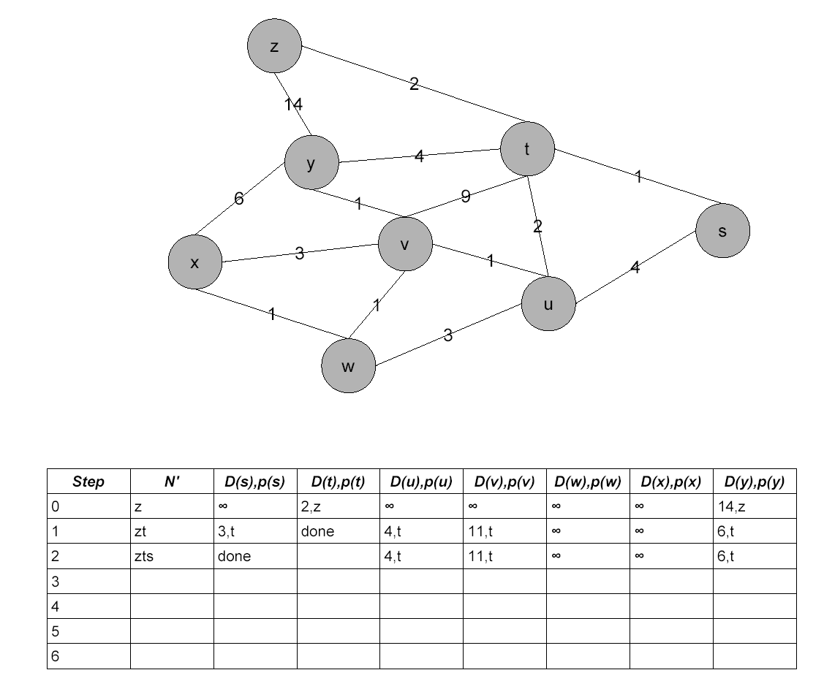
- Compare checksums and CRCs as a means of detecting errors. Discuss the tradeoffs between checksums and CRCs.
  - Checksums have a greater probability of undetected errors than do CRCs. That is, CRCs are better at detecting errors and will result in less undetected errors than checksums. CRCs are easily be computed in hardware, but not very easily in software. Checksums can be computed in software much faster than can CRCs.
- Compute the minimum possible frame size for a CSMA/CD protocol given the following parameters. Maximum medium span is 5000 meters (signal propagation is 5 nanoseconds per meter) and the data rate is 100-Mbps.
- What is jitter?
- What are two key application-level techniques for supporting multimedia on best-effort networks.
  - Two key application-level techniques are jitter buffering to remove packet-level delay jitter and Forward Error Correction (FEC) to reduce the effects of packet loss.
- Consider the network shown below and assume that each node initially knows the costs to each of its neighbors. Use the distance vector algorithm and complete the entire distance table below as it would look like at node z after the algorithm has converged.
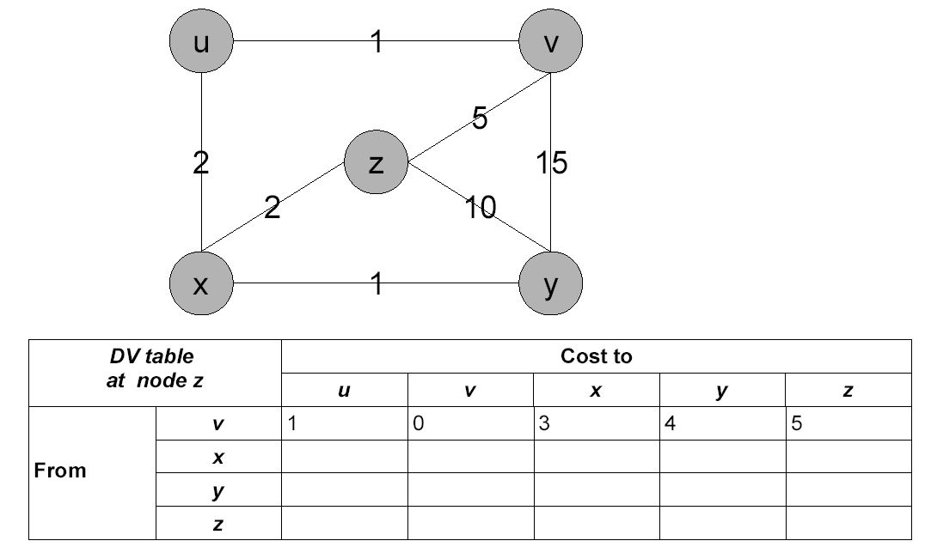
- Compare the link state and distance vector algorithms with respect to the following categories. Complete the table below.
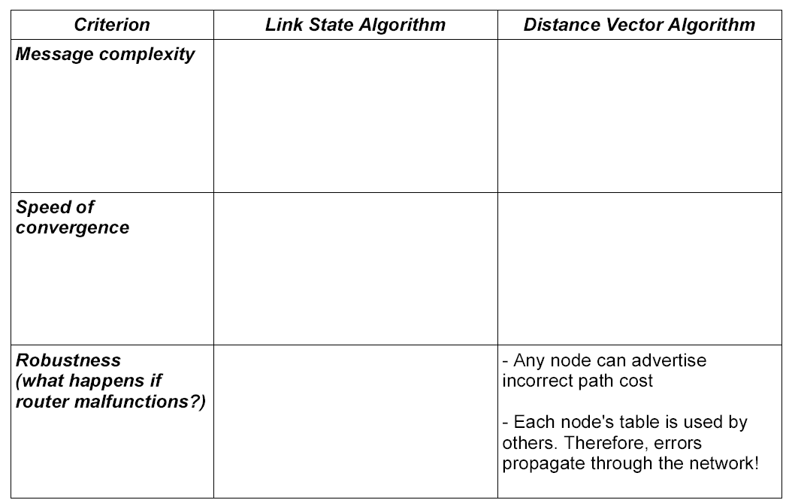
- The new service runs on top of TCP, and in the initial design, the server is implemented in a single process with the main body being:
listens at local port 6789
while (true) {
if (a new connection has finished three-way-handshake) {
create a connection socket from the connection
read the request from the new socket
process the request and write the reply to socket
close the connection socket
} // end of if
} // end of while
Joe’s friends argue that this design has problems. What are the major problems of this design and can you propose a fix?
- One problem of running TCP on long-delay links is the delay introduced by three-way-handshake (TWH). Some people propose that we remove TWH for long-delay links. Do you support or disagree with this proposal? Please justify.
- Consider a network with 8 nodes: A, B, C, D, E, F, G, and H. All links have length 1. We consider D as the destination. Using the synchronous Bellman-Ford algorithm (SBF), please compute the distances to D. The initial distance estimation of all nodes except D is ∞.
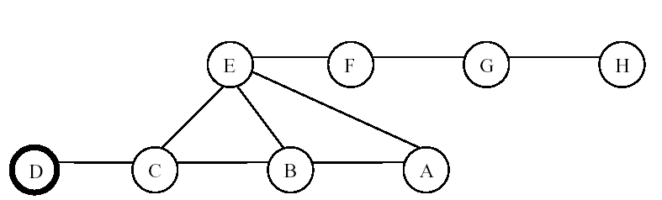
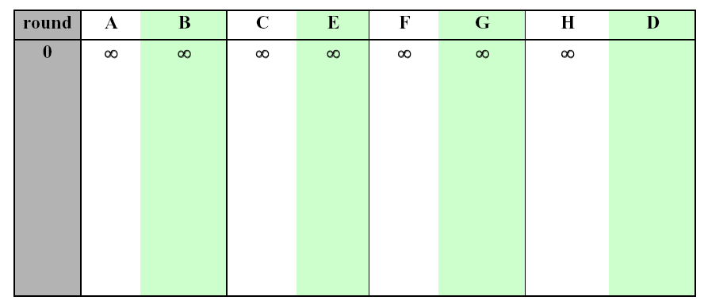
- Another issue facing Bell-Ford based algorithms is count-to-infinity. One way to address this problem is to use reverse poison. Can this technique completely prevent count-to-infinity in the sample network? If yes, please briefly justify. If no, please give a scenario.
- link state protocols face two problems in link state broadcast: link state sequence number reset after a router reboots and reconnection of two subnetworks after partition. How can these two problems be addressed?
- Consider the CRC generator polynomial G(x) = x⁴ + x² + x + 1. If the data frame is 10011010. What will be the transmitted bit stream, including both data and CRC?
- A modern car has many devices which should be connected by a LAN. There are many concurrent communications among the devices with different priorities; for example, a high priority session is that a control CPU needs to issue commands to brakes; a relatively low priority session is that the display needs to access the sensors measuring the outside temperature. For cost effectiveness, the manufacture wants the LAN to be based on Ethernet type random access. Can you propose a simple way to prioritize the access?
- Assume your home computer is connected through a NAT router to the Internet. Consider the following FTP-like file transfer protocol. The client first connects to a public file server using TCP to establish a control connection. To down file F, the client allocates a new port number P, and then sends to the server F and P. The server then initiates a new TCP connection to the client address at port P. Some one claims that this protocol will not work for our setup. Is this claim true?
- Consider the network shown below.
  - Show the operation of Dijkstra’s (Link State) algorithm for computing the least cost path from E to all destinations. Also, explicitly list the shortest path routes from E to all destinations that are the result of the algorithm’s computation.
  - Show the distance table that would be computed by the distance vector algorithm in B.
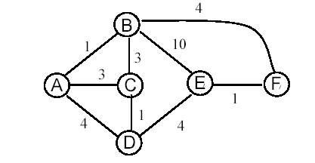
- What are the advantages and disadvantages of protocol layering?
- Which one is preferred for data networks: circuit switching or packet switching? Why?
- Why do HTTP, FTP, and SMTP run on top of TCP rather than UDP?
- Suppose the bandwidth on a point-to-point link is 1 Mbps and the one-way propagation delay is 4.5 ms. Assume that size of each packet is 125 bytes. Also assume that the size of ack packet is negligible. Assume that the sender always has data for transmission.
  - Assuming that the link is error-free, what should be the window size to achieve a throughput of 0.8 Mbps.
  - What is the minimum number of bits needed to represent the sequence number corresponding to the above window size?
  - Suppose two packets with sequence numbers 4 and 12 are lost during transmission. Assuming the above window size and the sequence number space, how many packets get retransmitted and what are their sequence numbers?
- A station on an Ethernet has tried to send its frame 3 times and collided each time. What is the interval over which the station will choose its next backoff delay? You may assume the slot time is 51.2 microseconds.
a. [0…7] times 51.2 microseconds
b. [1…8] times 51.2 microseconds
c. [0…15] times 51.2 microseconds
d. [1…16] times 51.2 microseconds
e. None of the above.
- Which of the following devices run a medium access control protocol when connected to an Ethernet segment?
a) Repeaters
b) Bridges
c) Routers
d) None of the above.
- Which of the following are true about Link State Routing (LSR)?
(a) LSR must use link delay as link cost metric.
(b) A router can receive the same link state advertisement message more
than once without network duplicating message
(c) LSR has a count to infinity problem
(d) LSR is typically used with small topologies of a few hundred nodes.
- Provide the NRZI and Manchester encoding for 001010110. Assume that the signal starts low for the NRZI coding.
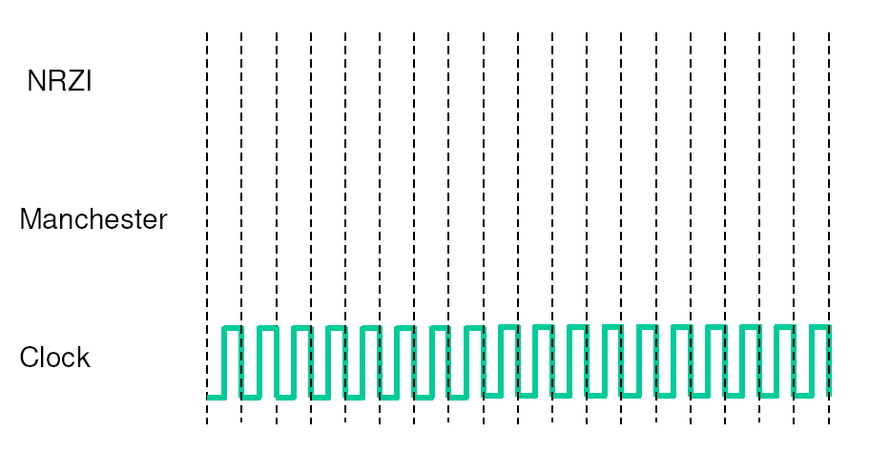
- What is the efficiency of (i) Manchester Encoding; and (ii) 4B/5B encoding?
- Assume that a B Kbps link is set up between Earth and a rover on Mars. The distance between Earth and Mars is approximately L meters. Data travels over the link at the speed of light – S m/s.
  - A camera on the rover takes pictures of the surroundings and saves them in digital format to disk . Suppose Mission Control on Earth wishes to download the most current image, which is M MB. What is the time that will elapse from when the request for data goes out from Misson Control, to when the picture is completely received?
  - Assume that the transmission in part (a) occurs in packets, with each packet containing P bytes of data, and H bytes of header. Present your modified answer to part (a). You may assume the image size M is an integral multiple of P.
- Explain the “hidden terminal problem” in 802.11 networks in 2-3 lines. Use a figure to aid the discussion, and provide an example.
- Consider the network below. Assume that the spanning tree algorithm is used. Complete the table below.
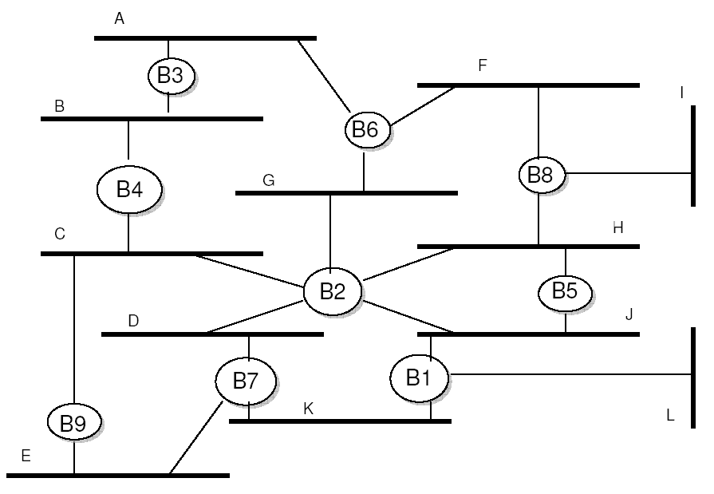
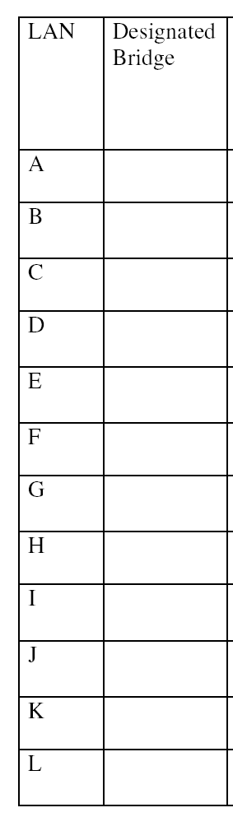
- The table below is a routing table using CIDR. Address bytes are in dotted decimal notation. The notation “/23” in 128.96.170.0/23 denotes a netmask with 23 leading 1 bits, that is, FF.FF.FE.0. State to what next hop the following will be delivered.
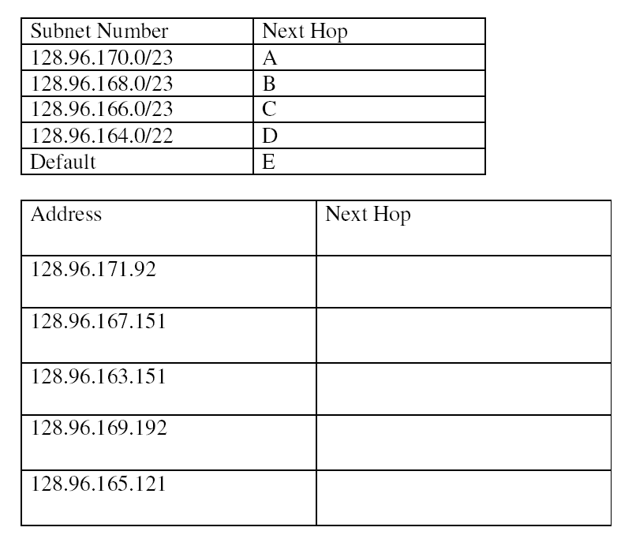
- A host A sends a stream of datagrams to a host B. All datagrams have the same size, 1024 bytes. It was observed that half the datagrams arrived unfragmented, but the other half of the datagrams arrived fragmented, with each fragment of size 512 bytes or less. Provide a likely and plausible explanation.
- Joe proposed that the entire Internet could be constructed with bridges, using the spanning tree algorithm and routers could be completely eliminated. Provide 2 reasons why this is a poor idea.
- If the longest allowed distance on a 100 Mbps Ethernet LAN is 1 kilometer, calculate the minimum time a busy station must sense the channel before assuming it is idle? What is the minimum packet length? Assume the speed of light is 3 x 10⁸ meters/second. (Note:1 kilometer = 1000meters)
- What does a repeater do? What layer of the protocol stack does it operate at?
- What is the difference between latency and delay?
- Consider the following network. With the indicated link costs, use Dijkstra’s shortest-path algorithm to compute the shortest path from D to all network nodes. Show how the algorithm works by computing a table similar to the table shown in class.
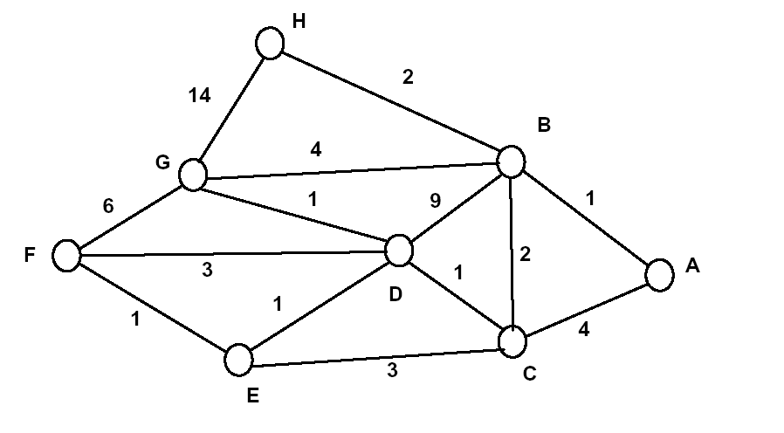
- Describe the original Classfull Internet Addressing scheme (i.e. class A, B, C, etc). What were the problems with this scheme? How does Classfull InterDomain Routing (CIDR) solve this?
- Functionally, the transport layer is similar to the data link layer. How are they different?
- Describe in some detail the flow control mechanism in TCP.
- Explain the meaning of the term cumulative ACK in a network protocol?
- During a job interview with TMC Ltd (True Mobile Computers), one of the managers is showing you the prototype of their new wireless Ethernet adaptor and he tells you that their R&D team has spent a lot of effort to design a state-of-the-art receiver that consumes extremely low power. He seems very excited with the potential of their new product, however, he is a little concerned because in a couple of experiments the collision detection algorithm did not work very well. During the conversation he mentioned that they have implemented the standard Ethernet CSMA\CD (carrier sense multiple access \ collision detection) and still there are some minor problems. How do you respond assuming that you really want to get the job?
- 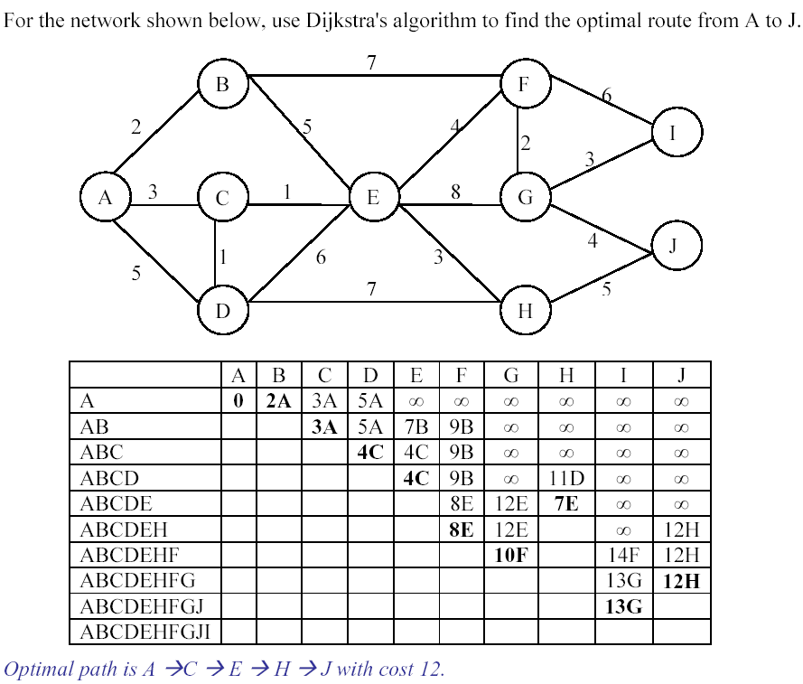
- Assume the link state algorithm. For the network shown above, what information should A share with the rest of the network? How is this information propagated?
- How do you envision the networks of 2020?
- In the figure below, a packet is arriving at an IP router connected to three Ethernets. IP addresses are shown in dotted decimal notation or denoted by upper case letters, while Ethernet addresses are denoted by lower case letters, and internal interface identifiers are integers. Draw the packet near the next Ethernet it will traverse. Include the addresses.
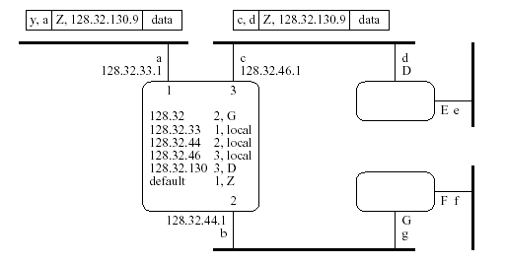
- How long does it take for a 3000-byte IP packet to go from host A to host B in the figure below? Assume the overhead of any packet headers is negligible, as is the length of the cables, and assume there is no other traffic. (If you need to make an additional assumption, state it.)
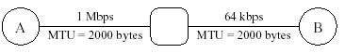

- Pretend for a moment that IP addresses are 12 bits instead of 32, and suppose you are allocated the block of addresses 1011xxxxxxxx for assigning addresses to hosts in four networks. Network A has 100 hosts, network B has 50, network C has 25, and network D has 20. Choose an address prefix for each network.

