به نام خدا
مدرس: مظفر بگ محمدي | دانشگاه ايلام | ترم دوم سال تحصيلي 86-85 | سري دوم تمرينات شبکه

- In one sentence, describe the major reason that we need to use longest prefix matching for packet forwarding.
- ICMP:
  - Explain briefly the relation between ICMP and IP.
  - Explain briefly the three (most usual) ICMP-message types.
  - Should a router give ICMP messages priority over normal traffic? Why or why not?
  - Give an example of an application that uses ICMP.
  - On top of which lower layer protocol does ICMP work?
- IP:
  - Write in decimal form the IP-address C22F1582. To which address class it belongs to? Write the address also in binary form.
  - What is the network part in the address 172.16.10.50/27? What is the host part?
- Consider the network shown below. Show the operation of Dijkstra’s (Link State) algorithm for computing the least cost path from E to all destinations. Also, explicitly list the shortest path routes from E to all destinations that are the result of the algorithm’s computation. Show the distance table that would be computed by the distance vector algorithm in B. Note: you do not have to run the distance vector algorithm; you should be able to compute the table by inspection.

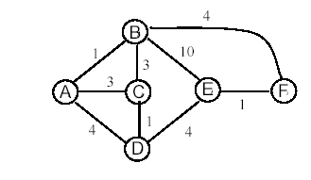

- Complete the following table, using Dijkstra's algorithm. Compute the shortest path from node z to all network nodes. Note: Possible ties are broken in favor of the leftmost column.
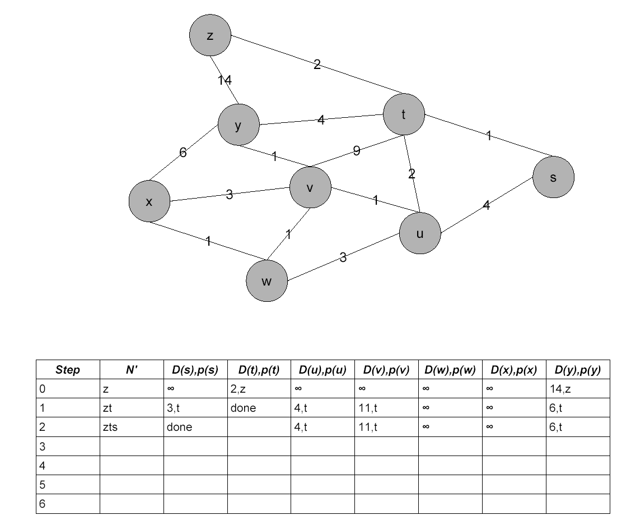

- Consider a network with 8 nodes: A, B, C, D, E, F, G, and H. All links have length 1. We consider D as the destination. Using the synchronous Bellman-Ford algorithm (SBF), please compute the distances to D. The initial distance estimation of all nodes except D is ∞.
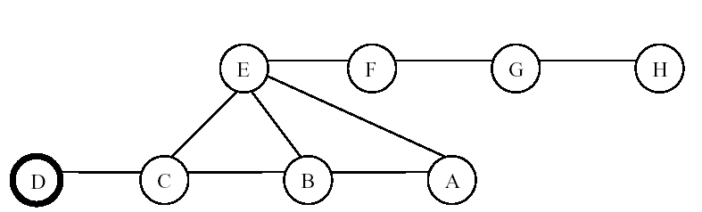
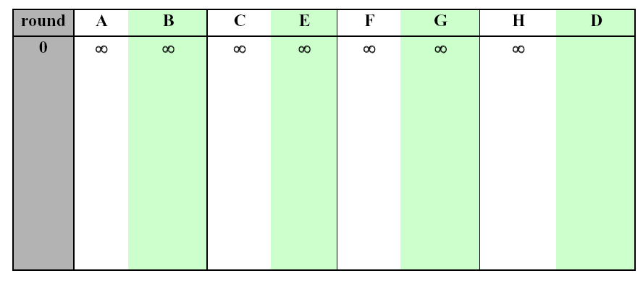
- Consider the network shown below and assume that each node initially knows the costs to each of its neighbors. Use the distance vector algorithm and complete the entire distance table below as it would look like at node z after the algorithm has converged.
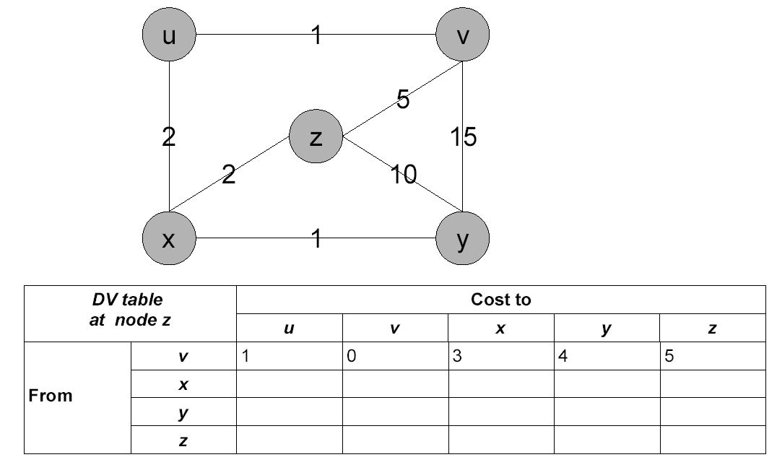
- The table below is a routing table using CIDR. Address bytes are in dotted decimal notation. The notation “/23” in 128.96.170.0/23 denotes a netmask with 23 leading 1 bits, that is, FF.FF.FE.0. State to what next hop the following will be delivered.

 